23362 | 23362
31642 | 23362
33757 | 24190.00001
23226 | 25146.70003
15178 | 24954.63002
7272 | 23976.967
4448 | 22306.47028
4926 | 20520.62322
5437 | 18961.16088
16498 | 17608.74477
35971 | 17497.67029
76556 | 19345.00329
68392 | 25066.10305
37447 | 29398.69281
15686 | 30203.52354
7942 | 28751.77116 | 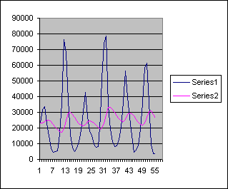
5123 | 26670.79402
7106 | 24516.01458
11250 | 22775.0131
18774 | 21622.51177
30508 | 21337.66059
42834 | 22254.69454
27345 | 24312.62512
17834 | 24615.86261
15386 | 23937.67634
9443 | 23082.50869
7599 | 21718.55781
8061 | 20306.602
27187 | 19082.04179
51511 | 19892.53762
74050 | 23054.3839
78773 | 28153.94559
33899 | 33215.85111
18886 | 33284.166
11520 | 31844.34938
8352 | 29811.91441
8660 | 27665.92294
12902 | 25765.33061
20331 | 24478.99753
36853 | 24064.19777
56407 | 25343.07802
39437 | 28449.47026
26761 | 29548.22325 |  |  | Alpha = 0.1
15185 | 29269.50092
4473 | 27861.05081
5781 | 25522.24569
9117 | 23548.12109
19267 | 22105.00896
36116 | 21821.20806
58850 | 23250.68728
61478 | 26810.6186
36300 | 30277.35679
9704 | 30879.62112
3410 | 28762.05898
3774 | 26226.85304

23362 | 23362
31642 | 23362
33757 | 25018.00003
23226 | 26765.80005
15178 | 26057.84003
7272 | 23881.87199
4448 | 20559.89754
4926 | 17337.51799 | 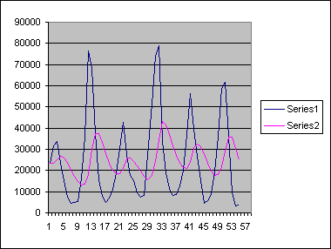
5437 | 14855.21435
16498 | 12971.57145
35971 | 13676.85717
76556 | 18135.68581
68392 | 29819.74882
37447 | 37534.19917
15686 | 37516.75934
7942 | 33150.6074
5123 | 28108.88585
7106 | 23511.70861
11250 | 20230.56684
18774 | 18434.45344
30508 | 18502.36276
42834 | 20903.49024
27345 | 25289.59226
17834 | 25700.67381
15386 | 24127.33903
9443 | 22379.0712
7599 | 19791.85692
8061 | 17353.2855
27187 | 15494.82837
51511 | 17833.26273
74050 | 24568.81029
78773 | 34465.04838
33899 | 43326.63883
18886 | 41441.11104
11520 | 36930.08876
8352 | 31848.07094
8660 | 27148.85668
12902 | 23451.08529
20331 | 21341.2682
36853 | 21139.21456 |  |  | Alpha = 0.2
56407 | 24281.97169
39437 | 30706.97745
26761 | 32452.98199
15185 | 31314.58557
4473 | 28088.66841
5781 | 23365.53466
9117 | 19848.62767
19267 | 17702.30211
36116 | 18015.24169
58850 | 21635.39341
61478 | 29078.31484
36300 | 35558.25197
9704 | 35706.60157
3410 | 30506.08118
3774 | 25086.86487

23362 | 29771.37524
31642 | 28800.82513
33757 | 24414.09501
23226 | 20802.85695
15178 | 16258.9141
7272 | 12794.94841
4448 | 10901.36902
4926 | 17415.62151 | 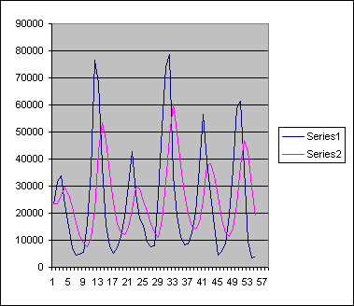
5437 | 31053.77311
16498 | 48252.26412
35971 | 60460.55866
76556 | 49835.93503
68392 | 37455.96084
37447 | 27081.57635
15686 | 19589.7457
7942 | 15217.84735
5123 | 14291.5084
7106 | 16707.30508
11250 | 24765.58317
18774 | 37422.15009
30508 | 38228.09007
42834 | 33641.25397
27345 | 26258.75227
17834 | 17544.45123
15386 | 12839.07067
9443 | 11350.24238
7599 | 14516.94548
8061 | 23156.56741
27187 | 37433.94066
51511 | 47051.56454
74050 | 42750.93866
78773 | 29532.163
33899 | 19083.29764
18886 | 29771.37524
11520 | 28800.82513
8352 | 24414.09501
8660 | 20802.85695
12902 | 16258.9141
20331 | 12794.94841
36853 | 10901.36902 |  |  |  | Alpha = 0.4
56407 | 17415.62151
39437 | 31053.77311
26761 | 48252.26412
15185 | 60460.55866
4473 | 49835.93503
5781 | 37455.96084
9117 | 27081.57635
19267 | 19589.7457
36116 | 15217.84735
58850 | 14291.5084
61478 | 16707.30508
36300 | 24765.58317
9704 | 37422.15009
3410 | 38228.09007
3774 | 33641.25397

23362 | 23362
31642 | 23362
33757 | 28330.0002
23226 | 31586.20021
15178 | 26570.07988
7272 | 19734.83168
4448 | 12257.13238
4926 | 7571.652764 | 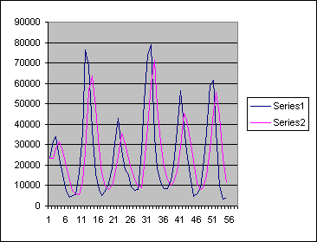
5437 | 5984.261043
16498 | 5655.904404
35971 | 12161.16202
76556 | 26447.06538
68392 | 56512.42735
37447 | 63640.17122
15686 | 47924.26786
7942 | 28581.30638
5123 | 16197.72206
7106 | 9552.888559
11250 | 8084.755365
18774 | 9983.902222
30508 | 15257.9611
42834 | 24407.9848
27345 | 35463.59436
17834 | 30592.43755
15386 | 22937.37472
9443 | 18406.54971
7599 | 13028.41967
8061 | 9770.767738
27187 | 8744.907054
51511 | 19810.16326
74050 | 38830.66606
78773 | 59962.26726
33899 | 71248.70735
18886 | 48838.88205
11520 | 30867.15211
8352 | 19258.86038
8660 | 12714.74389
12902 | 10281.89746 |  |  |  | Alpha 0.6
20331 | 11853.95905
36853 | 16940.18382
56407 | 28887.874
39437 | 45399.35026
26761 | 41821.93996
15185 | 32785.37563
4473 | 22225.14983
5781 | 11573.85951
9117 | 8098.143665
19267 | 8709.45749
36116 | 15043.98325
58850 | 27687.1938
61478 | 46384.87826
36300 | 55440.75167
9704 | 43956.30021
3410 | 23404.91927
3774 | 11407.96723

23362 | 23362
31642 | 23362
33757 | 30814.00079
23226 | 33462.70036
15178 | 24249.66906
7272 | 16085.16604
4448 | 8153.315764
4926 | 4818.531223 | 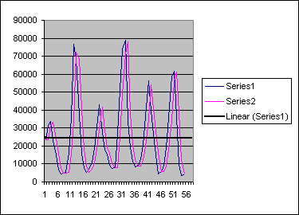
5437 | 4915.253133
16498 | 5384.825363
35971 | 15386.6836
76556 | 33912.57032
68392 | 72291.6611
37447 | 68781.96574
15686 | 40580.49359
7942 | 18175.44698
5123 | 8965.343723
7106 | 5507.234006
11250 | 6946.123553
18774 | 10819.61277
30508 | 17978.56204
42834 | 29255.0574
27345 | 41476.10704
17834 | 28758.10936
15386 | 18926.40989
9443 | 15740.04065
7599 | 10072.70347
8061 | 7846.370111
27187 | 8039.537032
51511 | 25272.25553
74050 | 48887.12806
78773 | 71533.71521
33899 | 78049.07221
18886 | 38314.00301
11520 | 20828.79845
8352 | 12450.87896
8660 | 8761.887505 |  |  |  | Alpha = 0.9
12902 | 8670.188741
20331 | 12478.81928
36853 | 19545.78268
56407 | 35122.27992
39437 | 54278.53002
26761 | 40921.15159
15185 | 28177.01381
4473 | 16484.20014
5781 | 5674.118869
9117 | 5770.311897
19267 | 8782.331509
36116 | 18218.53415
58850 | 34326.25512
61478 | 56397.62785
36300 | 60969.96327
9704 | 38766.99397
3410 | 12610.29663
3774 | 4330.028785

